# Rabbitmq3.8 Test

## Node Configuration

|  |  |  |  |  |  |
| --- | --- | --- | --- | --- | --- |
| Testing VM Confiugration | | | | | |
| Host IP | cpu | Mem | Disk | File Descriptor | Node Name |
| 10.10.10.84 | 8 core | 8G | 50G | 102400 | [rabbit@rabbitmq1](mailto:rabbit@rabbitmq1) |
| 10.10.10.85 | 8 core | 8G | 50G | 102400 | [rabbit@rabbitmq2](mailto:rabbit@rabbitmq1) |
| 10.10.10.86 | 8 core | 8G | 50G | 102400 | [rabbit@rabbitmq3](mailto:rabbit@rabbitmq1) |
| 10.10.10.87 | 8 core | 8G | 50G | 102400 | [rabbit@rabbitmq4](mailto:rabbit@rabbitmq1) |
| 10.10.10.88 | 8 core | 8G | 50G | 102400 | [rabbit@rabbitmq5](mailto:rabbit@rabbitmq1) |

## Test for 5 Nodes，5 Replicas

### 2.1、Test Data

Total: 100 vhosts、10k users、20k queues;

20 vhosts、2k users、4k queues for each node.

Each queue was set as quorum queue

### 2.2、Cluster Status and CPU Usage After Cluster Initiation

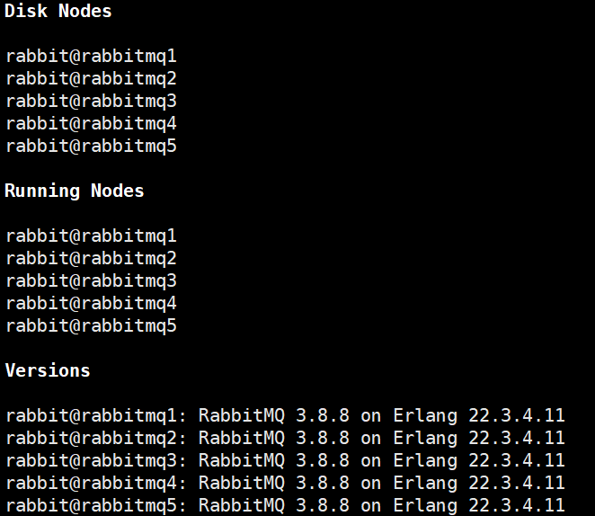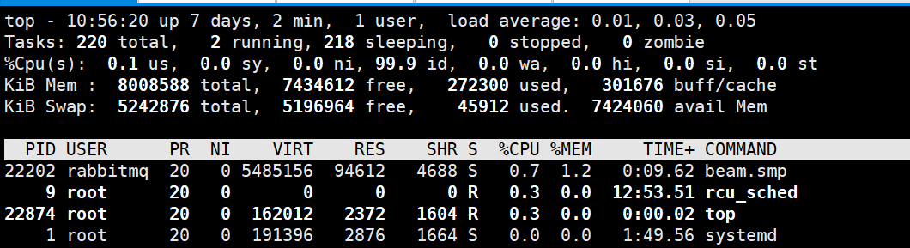

### 2.3、Cluster Status and CPU Usage After Importing Data

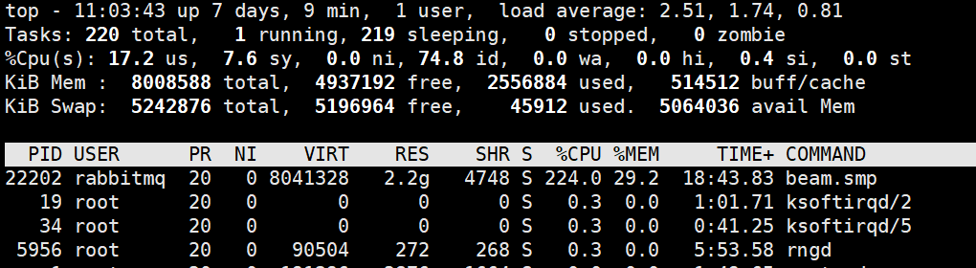

### 2.4、Stop Node rabbit@rabbitmq1, Check Quorum Status

Before shutdown，vhost:vhost1 queue status of queue1_rev:

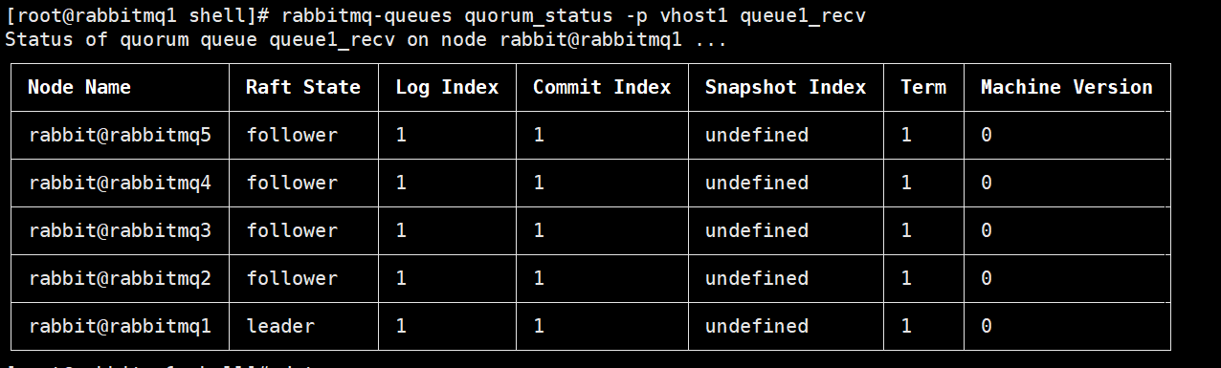

Stop rabbit@rabbitmq1 at 11:11:08

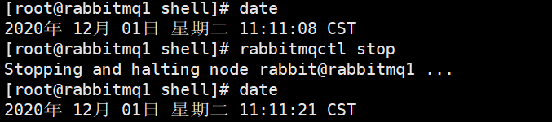

queue status of queue1_rev after 6 minutes:

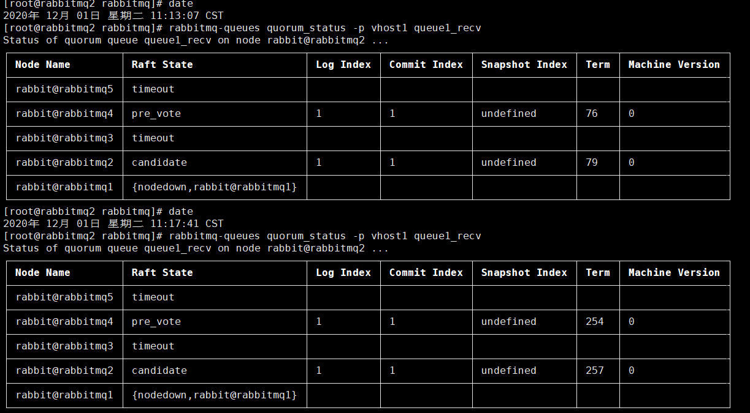

queue status of queue1_rev after 10 minutes:

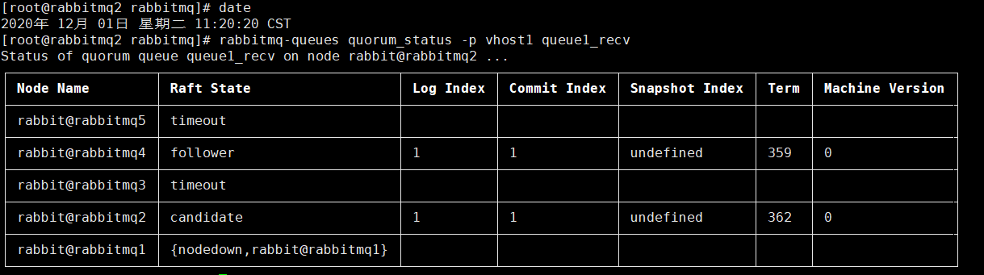

CPU Usage during the period of node stopping

